Ezitech Engineering Framework (EEF)
AI-020: AI Engineering Team Formation & Smart Project Allocation Engine
Day 1 Submission Checklist Kickoff & Environment

1. Submission Details
Student Name | Husnain Ali
Registration No. | Fa23-bse-003
Team Member(s) | Muhammad Ahsan Fawad
Case Study | AI-020: AI Engineering Team Formation & Smart Project Allocation Engine
Submission Date | 14-jul-2026
GitHub Repository Link | https://github.com/husnainali234/AI-Engineering-Team-Formation-Smart-Project-Allocation-Engine

2. Day 1 Deliverable Checklist
Tick each item once verified on your own machine before submission. Every row must have either evidence text/link or a corresponding screenshot in Section 3.
# | Checklist Item | Status (Pending / Done) | Evidence / Notes / Link
1 | docker compose up --build starts both containers (db + backend) with no errors | Done
2 | GET /health returns {"api": "ok", "database": "ok"} | Done
3 | GET /docs loads the Swagger UI successfully | Done
4 | app/models.py defines all entities (Intern, Skill, InternSkill, Project, Team, TeamMember, TeamHistory, MentorFeedback, Attendance) and imports cleanly | Done
5 | ERD diagram (draft) is completed and committed to the repository | Done
6 | .env is excluded via .gitignore; .env.example is committed instead | Done
7 | First commit created and pushed to GitHub | Done

3. Evidence / Screenshots
Required Screenshot | Paste Screenshot Below / Attach Filename
Terminal output of docker compose up --build (both containers healthy) | 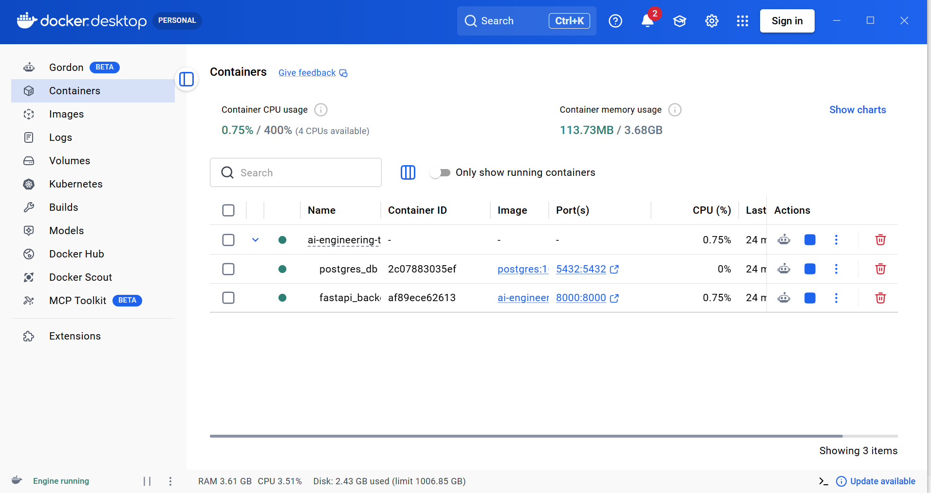
Browser screenshot of GET /health response | 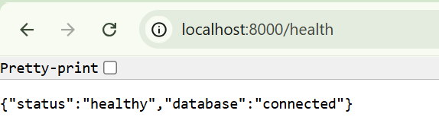
Browser screenshot of /docs Swagger UI | 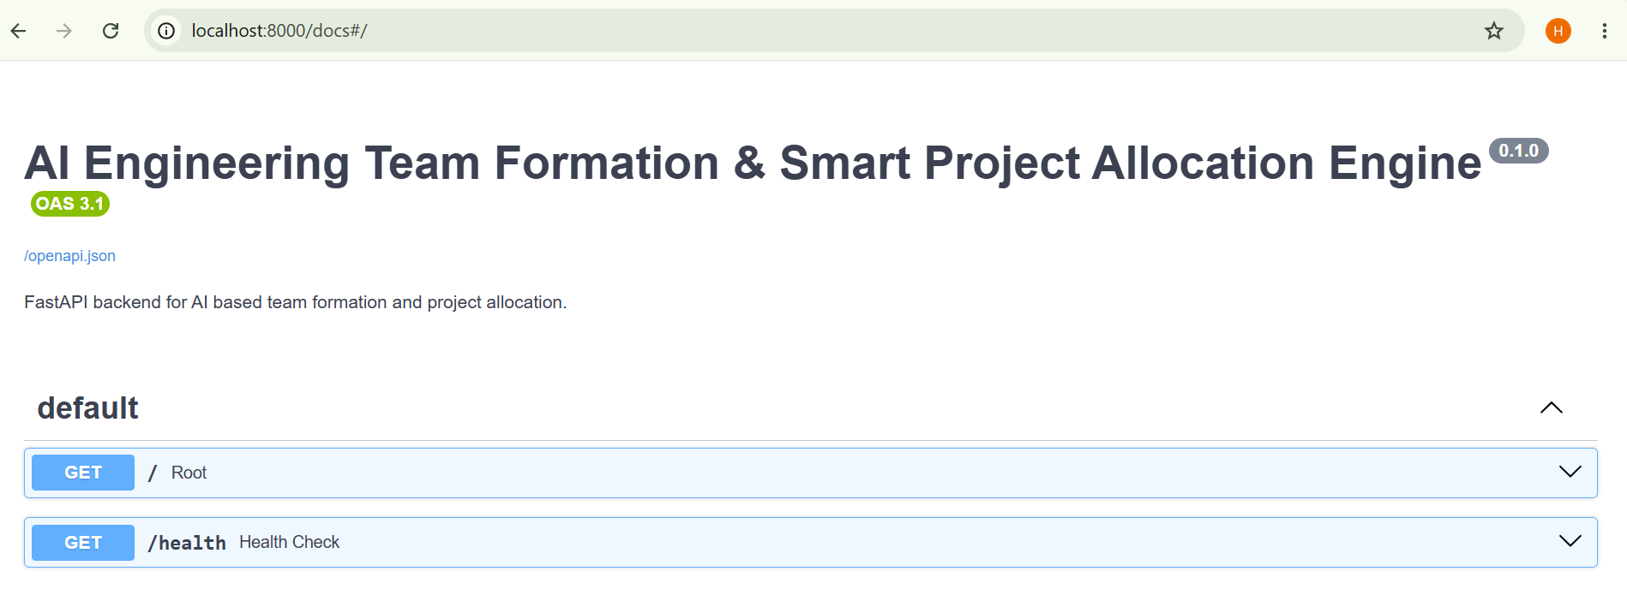
ERD diagram (mermaid render or draw.io export) | 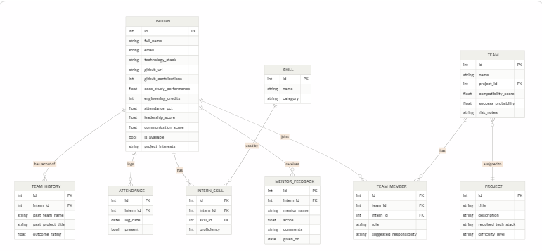

4. Brief Summary (2–4 sentences)
Describe what was set up today, any blockers encountered, and what is planned for Day 2.
Today I set up the project foundation by creating a FastAPI backend, configuring PostgreSQL with Docker Compose, establishing the SQLAlchemy database connection, and implementing the initial ERD models. I also configured Docker for development with live reload and verified that both the API and PostgreSQL containers were running successfully. The main blocker was resolving Docker and PostgreSQL configuration issues, including the missing .env file and database environment variables. On Day 2, I plan to create the database schema using Alembic migrations, seed the database with sample data, and begin implementing the backend CRUD API

5. Sign-Off
Submitted By (Signature) | Date | Mentor Remarks
Husnain Ali | 14-jul-2025

